玉环新城（漩门三期）城市设计方案
国际征集
International Urban Design Competition for
Yuhuan New City(Xuanmen Phase III)

（技术任务书）
（Design Brief）

目录
Table of Contents
一、 项目背景 3
I. Project Context 3
二、 项目区位 5
II. Project Location 5
三、 项目规划设计范围 7
III. Planning and Design Scope 7
四、 各阶段任务内容 9
IV. Design Contents in Each Stage 9
(一) 设计方案竞赛及评审阶段 9
（I）Design Proposal Competition and Evaluation Stage 9
1. 概念规划层面 9
1. Conceptual Planning 9
2. 整体城市设计层面 12
2. Overall Urban Design 12
3. 详细城市设计层面 15
3.Detailed Urban Design 15
(二) 成果整合深化阶段 18
（II）Deepen Stage of Submissions 18
1. 规划设计方案整合 19
1. Integration of Planning and Design Schemes 19
2. 详细城市设计范围内图则编制 19
2. Drawing preparation within the scope of detailed urban design 19
五、 各阶段成果要求 20
V. Requirements for The Submissions of Each Stages 20
(一) 设计方案竞赛及评审阶段 20
（I）Design Proposal Competition and Evaluation Stage 20
1. 成果要求 20
1. Submission Requirements 20
2. 成果形式 22
2. Outcome Form 22
(二) 成果整合深化阶段 23
（II）Deepen Stage of Submissions 23
六、 提供资料及格式 24
VI. Relevant Information and Format 24
(一) 工作基础图纸 24
（I）Work Basic Drawings 24
(二) 相关规划资料 24
（II）Relevant Information 24

项目背景

I. Project Context
玉环市位于浙江省台州市南部，具备富有海湾特色的自然资源，境内岛屿林立，海礁棋布，主要地貌类型为丘陵和平原；海洋资源丰富，海洋自然风光优美，海岛文化特色显著；集港口航道、岸线、渔业、旅游、海洋等资源于一体，组合优势明显。另外，玉环市是全国综合实力百强县，2021年玉环GDP总量为711.39亿元，工业经济突出，民营经济活跃，是温台模式典型代表。
Yuhuan City, located in the south of Taizhou City, Zhejiang Province, with natural resources rich in bay characteristics, and the territory is full of islands and sea reefs, the main landform types are hills and plains. Yuhuan is rich in marine resources, beautiful natural scenery, and distinctive island culture. At the same time, Yuhuan has obvious advantages in combination with port channels, shorelines, fishery, tourism, ocean and other resources. In addition, Yuhuan is one of the top 100 counties with comprehensive strength in China. The total GDP of Yuhuan in 2021 was 71.139 billion yuan, with prominent industrial economy and an active private economy, which is a typical representative of the Wen-Tai model.
近年来，随着甬台温高速通车、杭绍台高铁的建设，区域交通的改善使玉环迎来新的发展机遇。同时，在撤县设市后，能级的提升也向城市建设提出新的要求。
In recent years, with the opening of the Ningbo-Taizhou-Wenzhou Conventional Expressway, and the construction of the Hangzhou-Taizhou High-speed Railway, the improvement of regional transportation has brought new development opportunities to Yuhuan. At the same time, the enhancement of the city's capacity brought by withdrawal of county and establishment of city also puts forward new requirements to the city construction.
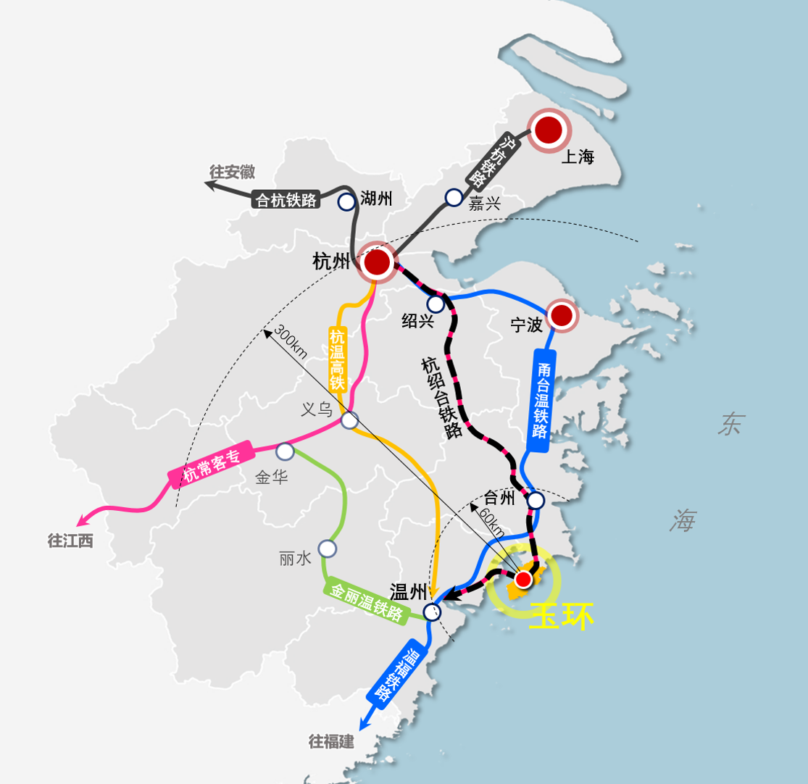
- 玉环市区位图
Fig. 1 Location of Yuhuan
玉环新城（漩门三期）位于玉环市地理中心区位，连接本岛与半岛的多个镇街，并通过漩门湾与漩门二期新城贯通。在国土空间规划中，玉环新城（漩门三期）将与漩门二期、高铁新区共同构建带状城市中心，承载城市级公共服务、产业创新服务，彰显海岛特色。作为打造“一极三城”、建设“四个玉环”的重要片区及玉环未来15年城市建设的主战场，玉环新城（漩门三期）是玉环聚力城市蝶变“提级”，优化城市功能，联动新老城，辐射周边板块的战略空间。同时，也是构筑玉环海湾城市“新形态”，提升城市形象和品质，打造具有玉环特色风情的海上花园之城的特色空间。
Yuhuan New City(Xuanmen Phase III)is located in the geographical center of Yuhuan，which is connected to several towns and streets of the peninsula, and connecting with Xuanmen Phase II New Ctiy through the Xuanmen Bay. In the Territorial Spatial Planning of Yuhuan City, Yuhuan New City(Xuanmen Phase III)， Xuanmen Phase II and high-speed rail New City will jointly build a belt shaped urban center，which carrying urban public and industrial innovation services, and highlighting the characteristics of the island. As an important area to build "one pole, three cities and four Yuhuan" and the main battlefield for Yuhuan's urban construction in the next 15 years, Yuhuan New City(Xuanmen Phase III) is a strategic space for Yuhuan to upgrade its urban level, to optimize urban functions, to link the new and old cities and radiate the surrounding plates. At the same time, it is a special space to enhance the image and quality of the city, to build a "New form" of Yuhuan Bay City, and to create a city of sea gardens with Yuhuan's special style.
本次国际竞赛旨在通过国内外优秀规划设计机构集思广益，征集兼具未来性、创意性与实施性的概念规划及城市设计方案。
This international competition intends to call for urban design proposals from outstanding domestic and international design institutions, which should be future-oriented, creative and implementation-oriented conceptual.

项目区位

II. Project Location
玉环市属浙江省辖县级市，由台州市代管。位于浙江东南沿海、中国黄金海岸线中段，长三角经济圈南翼，东濒东海，南濒洞头洋与温州市洞头区相连，西北隔乐清湾与乐清市相望，东北与温岭市接壤。
Yuhuan is a county-level city in Zhejiang Province, entrusted by Taizhou City. It is located in the southeast coast of Zhejiang Province, the middle of China's golden coastline and the southern wing of the Yangtze River Delta economic circle. The eastern boundary of Yuhuan is bordering on the East China Sea, the southern boundary is connected with Dongtou’s Sea and Dongtou District of Wenzhou, the northwestern boundary is connected with Yueqing Bay and Yueqing, and the northeastern boundary is bordering on Wenling.
玉环新城（漩门三期）位于漩门湾东部，北接干江镇、龙溪镇，西与玉环本岛接壤，东南与鸡山隔海相望。玉环新城（漩门三期）兼具“中心+枢纽”区位优势，是玉环市中心城区未来发展的重要片区。玉环新城（漩门三期）对外交通便利，通过甬莞高速、文旦大道对外联系；对内通过芦北大道、滨江大道与漩门二期、楚门联系，通过环岛路与大麦屿、干江联系。
Yuhuan New City(Xuanmen Phase III) is located in the east of Xuanmen Bay, it is defined by Ganjiang Town and Longxi Town on the north, Jishan Town on the southeast. Yuhuan New City(Xuanmen Phase III) is an important area for the future development of Yuhuan which with the location advantages of “Centre and Pivot”. Yuhuan New City(Xuanmen Phase III) has convenient transportation and is connected with the external areas through Ningbo Dongguan Expressway and Wendan Avenue. Internally, Yuhuan New City(Xuanmen Phase III) connected with Xuanmen Phase II New city and Chumen town through Lubei Avenue and Binjiang Avenue, and with Damaiyu town and Ganjiang town through Huandao Road.
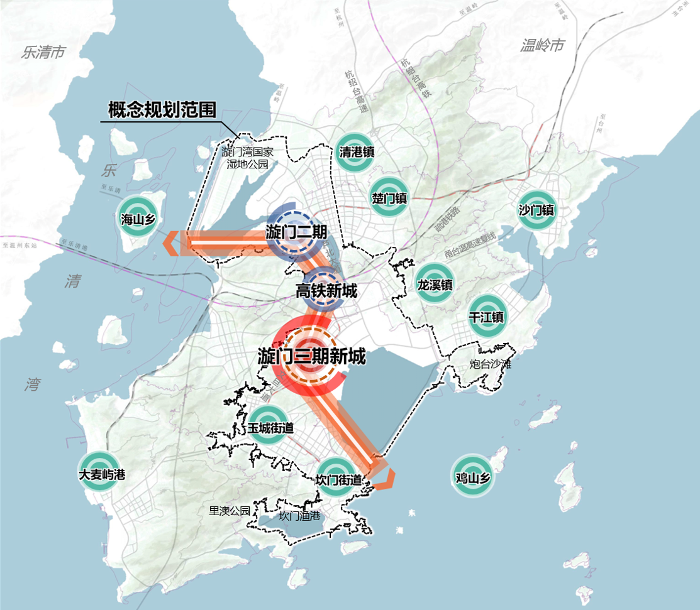
- 玉环新城（漩门三期）区位图
Fig. 2 Location of Yuhuan New City(Xuanmen Phase III)

项目规划设计范围

III. Planning and Design Scope
本次项目工作范围按内容及深度不同分三个层面，分别为概念规划范围、整体城市设计范围以及详细城市设计范围。
The scope of this project is divided into three levels according to the content and depth, which are Conceptual Planning scope, Overall urban design scope and Detailed urban design scope.
- 概念规划范围：玉环新城（漩门三期）协调发展片区，总面积约145平方公里；北至漩门湾湿地公园，东至泽坎公路、炮台山炮台沙滩，南至东沙渔村，西至山体边界。
（I） Conceptual Planning Scope：Yuhuan New City(Xuanmen Phase III) coordinated development area, which extends to the Xuanmen Bay Park in the north, the Zekan Road and Paotai Mountain in the east, Dongsha Fishing Village in the south and the mountain boundary in the west, covering a total area of 145 k㎡.
- 整体城市设计范围：玉环新城（漩门三期）及周边区域，由自然河道、山体边界、海岸线围合，面积约38.5平方公里的区域；北至文旦大道，东至龙翔南路，南至现状海陆边界、坎门海洋经济示范园，西至山体边界。
（II）Overall Urban Design Scope：Yuhuan New City(Xuanmen Phase III) surrounding areas, which are surrounded by natural rivers, mountain boundaries and coastlines, covering a total area of 38.5k㎡. Yuhuan New City(Xuanmen Phase III) extends to the Wendan Avenue in the north, the Longxiang South Road in the east, the current Land and Maritime Boundary, the Kanmen Marine Economy Demonstration Zone in the south and the mountain boundary in the west.
- 详细城市设计范围：玉环新城（漩门三期）中心片区，总面积约10平方公里；北至文旦大道、甬莞高速，西至城镇开发边界及山体边界，东、南至规划水系。其中，重点地块设计范围约1.75平方公里，为行政文化片区及前面公园、商业用地；北至文旦大道，东、南至规划主干道，西至东海大道。
（III）Detailed Urban Design Scope：Yuhuan New City(Xuanmen Phase III) Central area, which extends to the Wendan Avenue and Ningbo–Dongguan Expressway in the north, the Urban Growth Boundary and the mountain boundary in the west, and the planned river system in the east and south. Among them, the Key node detailed urban design scope which includes administrative culture, park and commercial land, covering a total area of 1.75k㎡. the Key node detailed urban design scope extends to the Wendan Avenue in the north, the Donghai Avenue in the west, the planned main road in the east and south.
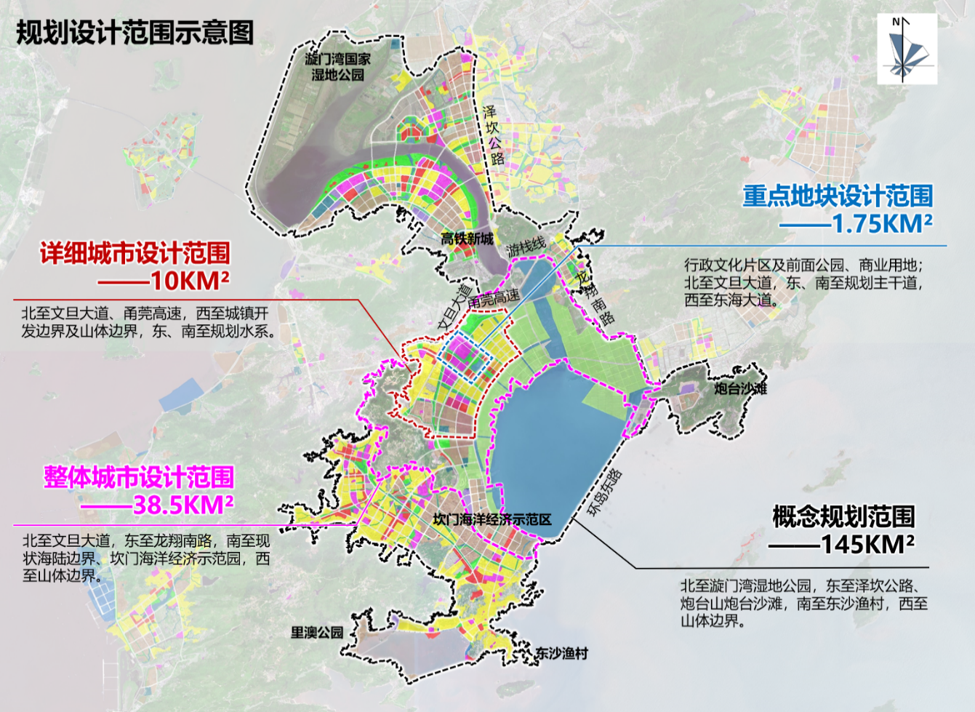
- 规划设计范围示意图
Fig. 3 Planning and Design Scope

各阶段任务内容

IV. Design Contents in Each Stage

设计方案竞赛及评审阶段

（I）Design Proposal Competition and Evaluation Stage

概念规划层面

1. Conceptual Planning
解读相关政策及玉环市国土空间总体规划等上位规划要求，明确玉环新城（漩门三期）未来发展的宏观政策导向、空间建设要求；梳理研究区域海湾特色、山海生态格局、人文历史本底及陆海国土现状本底，识别项目未来发展问题及挑战，通过城市空间格局研究、功能协同发展研究、综合交通衔接研究，明确玉环新城（漩门三期）总体战略定位，梳理玉环新城（漩门三期）与老城、漩门二期及周边镇区的关系，借力高铁枢纽区位优势，判断玉环新城（漩门三期）未来的发展机遇及动力，并提出面向未来的发展思路与策略。
Interpret the Territorial Spatial Planning of Yuhuan City and related administrative planning requirements, to clarify the macro policy orientation and spatial construction requirements for the future development of Yuhuan New City(Xuanmen Phase III). Sort out the characteristics of the bay, the ecological pattern of mountains and seas, the background of human history and the current situation of land and ocean, to identify the future development problems and challenges of the project. The overall strategic positioning of Yuhuan New City(Xuanmen Phase III) is clarified through the study of urban spatial pattern, functional coordinated development and comprehensive transportation connection. By sorting out the relationship between Yuhuan New City(Xuanmen Phase III), the old city, Xuanmen Phase II and the surrounding towns, and taking advantage of the location advantages of the high-speed railway hub, the future development opportunities and driving forces of Yuhuan New City(Xuanmen Phase III) are judged, and the development ideas and strategies for the future are proposed.
- 总体战略定位
（1）Overall Strategic Positioning
站在海上丝绸之路、浙江省大湾区建设、大通道建设、大花园建设等区域战略视角的维度上，立足玉环自身的城市特征，研究国内外的案例经验，对外深入研究玉环市的城市发展面临的机遇与挑战，对内站在玉环市整体发展的角度上，重点考虑与漩门二期联动、与周边城镇的协作，从宏观层面审视玉环新城（漩门三期）的战略价值及未来发展大方向和大趋势，并提出玉环新城（漩门三期）的战略定位及发展目标。
Based on relevant planning research, starting from the regional background resources, combined with the advantages of transportation, ecology, geographical location and so on, fully excavate the value of regional background resources, and emphasize on the collaborative connection between the area and the surrounding areas, so as to propose the goal and vision of urban design. According to the overall strategic positioning of the city, refine the urban functional layout and spatial pattern, and optimize the ecological pattern, spatial pattern, transportation pattern, etc. Shape the urban spatial form and show the features of island cities; Emphasize on the layout of urban public space system under the characteristics of mountains, rivers and seas; Propose the action plan for the future phased development and construction of Yuhuan New City(Xuanmen Phase III).
- 总体发展策略
（2）Overall Development Strategy
在战略定位下，梳理玉环新城（漩门三期）与漩门二期及周边镇区、高铁片区的关系，判断玉环新城（漩门三期）未来的发展机遇及动力，充分研究国内外具有可比性的案例，结合现状已布局、拟布局的重大设施，并提出面向未来的发展思路与策略。同时，结合玉环新城（漩门三期）的发展思路，对漩门二期、老城、周边镇区等提出统筹发展的创新思路（可根据需要，提出创新建议，不限于目标定位、功能布局、重大设施、开发模式等）。
According to the strategic positioning to sort out the relationship between Yuhuan New City(Xuanmen Phase III), Xuanmen phase II, the surrounding towns and high-speed rail areas, to judge the future development opportunities and driving forces of Yuhuan New City(Xuanmen Phase III). Fully study the domestic and foreign comparable cases, combined with the current situation and planning of major facilities, and propose development ideas and strategies for the future. At the same time, combined with the development ideas of Yuhuan New City(Xuanmen Phase III), propose innovative ideas for the overall development of Xuanmen phase II, the old city and the surrounding towns (innovative suggestions can be proposed as needed, not limited to target positioning, functional layout, major facilities, development mode, etc.).

整体城市设计层面

2. Overall Urban Design
基于相关规划研究，从区域的本底资源着手，结合交通、生态、地理位置等优势充分挖掘区域本底资源价值，并注重片区与周边区域的协同衔接，提出城市设计的目标愿景；根据城市总体战略定位，细化城市功能布局与空间格局，优化生态格局、空间格局、交通格局等；塑造城市空间形态，展现海岛城市风貌特色；注重山、河、海特质下的城市公共空间系统的布局；提出玉环新城（漩门三期）未来分期开发建设的行动计划。
Based on relevant planning research, starting from the regional background resources, combined with the advantages of transportation, ecology, geographical location and so on, fully excavate the value of regional background resources, and emphasize on the collaborative connection between the area and the surrounding areas, so as to propose the goal and vision of urban design. According to the overall strategic positioning of the city, refine the urban functional layout and spatial pattern, and optimize the ecological pattern, spatial pattern, transportation pattern, etc. Shape the urban spatial form and show the features of island cities; Emphasize on the layout of urban public space system under the characteristics of mountains, rivers and seas; Propose the action plan for the future phased development and construction of Yuhuan New City(Xuanmen Phase III).
- 目标愿景及形象定位
（1）Target Vision and Image Positioning
通过研判玉环新城（漩门三期）的未来发展格局，充分研究分析片区生态、交通、区位、文化等本底资源价值与环境特色，提出玉环新城（漩门三期）具有吸引力和特色鲜明的空间发展目标愿景与特色形象定位。
Based on the evaluation of the future development pattern of Yuhuan New City(Xuanmen Phase III), and the full study and analysis of the ecological, traffic, location, culture and other background resource values and environmental characteristics of the area, the paper puts forward the attractive and distinctive spatial development goal vision and characteristic image positioning of Yuhuan New City(Xuanmen Phase III).
- 功能布局与空间结构
（2）Functional Layout and Spatial Structure
基于目标愿景，对玉环新城（漩门三期）的空间功能进行布局，对片区结构进行整体空间重塑，建立适应未来发展、秩序清晰、弹性适应的功能板块布局。建立山海联系、蓝绿交织、开放共享的规划结构，统筹考虑与漩门二期、高铁新城、老城、老镇等周边功能板块的空间协同关系及联系通道，对既有产业空间提出未来发展和空间品质提升的方案。
Based on the goal and vision, the spatial function of the Yuhuan New City(Xuanmen Phase III) is arranged, and the overall spatial structure of the area is reshaped, so as to establish a functional plate layout with clear order and flexible adaptation for future development. Through the establishment of the planning structure of coordination, green-tech, open-minded and mutural-share, and overall consideration of the spatial synergistic relationship and connection channel with surrounding functional blocks such as Xuanmen Phase II New City, high-speed railway new town and old town, the existing industrial space is proposed for future development and space quality improvement.
- 土地利用规划
（3）Land-use Planning
考虑国土空间总体规划的控制性要素（如城镇集中建设区、城镇弹性发展区、海陆分界线等），根据目标愿景、功能布局与空间结构等，结合现状土地实际情况，细化土地利用规划布局。对当前国土空间规划提出的城镇开发边界以外的暂时无法用于建设的土地空间进行研究，提出土地利用方式的建议。
Considering the controlling elements of the Territorial Spatial Planning of Yuhuan City(such as Urban centralized construction area, urban flexible development area and sea land boundary). According to the target vision, functional layout and spatial structure, etc., combined with the actual use of the current land, refine the land use planning layout. This paper studies the land space beyond the urban development boundary proposed by the current the Territorial Spatial Planning of Yuhuan City that cannot be used for construction temporarily, and puts forward suggestions on land use methods.
- 城市形态格局与风貌特色引导
（4）Urban Spatial Form and Cityscape Features
从玉环新城（漩门三期）整体的山、河、海格局出发，妥善处理城市与自然要素的空间关系，以塑造优美的空间形象与高水准的空间品质为目标，构建玉环新城（漩门三期）的整体城市形态格局。通过对空间景观节点、建设高度、开发强度、天际线、生态廊道及景观视线等要素的控制引导，打造特色鲜明的海岛城市空间形象，并提出片区城市风貌的分区指引。
Starting from the overall mountain, river and sea pattern of Yuhuan New City(Xuanmen Phase III), properly handle the spatial relationship between the city and natural elements, and build the overall urban morphological pattern of Yuhuan New City(Xuanmen Phase III) with the goal of shaping a beautiful spatial image and high-level spatial quality. Through the control and guidance of spatial landscape nodes, construction height, development intensity, skyline, ecological corridor and landscape line of sight, we can create a distinctive spatial image of the island city, and propose zoning guidelines for the urban style of the area.
- 公共空间系统规划
（5）Open Space System Planning/Public Space
梳理并优化城市生态空间、公共空间，突出地域文化、人文精神和场所功能性与体验性，统筹安排与城市功能高度契合、山海与人和谐互动的公共空间系统，强化玉环新城（漩门三期）的城市活力与空间品质，并系统策划相关城市活动。
Sorting out and optimizing urban ecological space and public space, highlighting regional culture, humanistic spirit and place functionality and experience. The public space system, which is highly compatible with urban functions and harmonious interaction between mountains, sea and people, will be arranged to strengthen the urban vitality and spatial quality of Yuhuan New City(Xuanmen Phase III), and systematically plan related urban activities.
- 综合交通系统规划
（6）Comprehensive Traffic System Planning
结合上位交通规划及现状交通情况，充分衔接周边功能板块，重点考虑高铁站点与玉环新城（漩门三期）的联动效益，提出综合的交通系统设计方案；完善城市交通系统，对道路布局、公共交通、慢行系统等内容进行优化完善。
Combined with the upper traffic planning and the current traffic situation, fully connecting the surrounding functional plates, focusing on the linkage benefits of high-speed rail stations and the Xuanmen phase III new city and proposing a comprehensive traffic system design. Improving the urban transportation system, optimizing and perfecting the road layout, public transportation and the slow-moving system.
- 实施行动计划
（7）Implementation of Action Plan
基于城市运营的思路，提出具有可操作的玉环新城（漩门三期）的近、中、远期城市开发建设实施计划。
Based on the idea of urban operation, this paper puts forward the short-term, medium-term and long-term urban development and construction implementation plans of Yuhuan New City(Xuanmen Phase III).

详细城市设计层面

3.Detailed Urban Design
针对详细城市设计层面，细化玉环新城（漩门三期）中心片区功能布局，并提出重点项目的策划；以提升城市空间品质为目标，研究开放空间、廊道界面、建筑形态、交通组织、环境景观等城市设计要素，细化城市形态风貌和空间环境品质的管控要求；对城市重要地块进行概念性设计，塑造城市空间形象与特色；并对重点地块进行城市设计图则的示例。
In view of the detailed urban design, the functional layout of the central area of Yuhuan New City(Xuanmen Phase III) is refined, and the planning of key projects is proposed. With the goal of improving the quality of urban space, urban design elements such as open space, corridor interface, architectural form, traffic organization and environmental landscape are studied, and the control requirements of urban form and style and spatial environmental quality are refined. The conceptual scheme design is carried out for the important urban plots to shape the image and characteristics of the urban space, and the examples of the urban design plan are given for the key plots.
- 重点项目策划
（1）Key Project Planning
以整体城市设计的空间结构与用地功能为基础，从促进片区整体开发、突出片区特色的角度出发，提出重点项目的策划（项目类型、大小规模均不做限制，如产业项目、公共服务、基础设施、景观空间等），并对既有项目（待落实）提出功能、规模或开发方式的优化建议。
Based on the spatial structure and land use function of the overall urban design, from the perspective of promoting the overall development of the area and highlighting the characteristics of the area, this paper puts forward the planning of key projects (the type and size of projects are not limited, such as industrial projects, public services, infrastructure, scenic space, etc.), and puts forward optimization suggestions on the function, scale or development mode of existing projects (to be implemented).
- 公共空间设计
（2）Open Space Design
基于设计理念与思路，识别中心片区的重要轴线、廊道、街区、界面等重要空间要素，对其形态与特色提出设计引导要求。明确需要重点引导的公共空间，提出公共空间的布局、主题功能、面积规模、环境景观特色等，塑造各类宜人的开放空间。
Based on the design concept and thinking, the important spatial elements such as axis, corridor, block and interface of the central area are identified, and the design guidance requirements for its form and characteristics are proposed. The public space that needs to be guided is clearly defined, and the layout, theme function, area scale, environment and landscape characteristics of the public space are proposed to shape all kinds of pleasant open space.
- 道路交通设计
（3）Road Traffic Design
对中心城区内的交通系统组织进行细化，为片区建立建设高质量、连续的慢行交通网络，对特色街道及主要形象道路进行典型街道断面设计，并对人行过街设施、主要立体交通节点优化提出合理建议。
The organization of the traffic system in the central city is refined to establish a high-quality and continuous slow traffic network for the area. The typical section of characteristic streets and main image roads is designed, and reasonable suggestions are proposed for the optimization of pedestrian crossing facilities and main three-dimensional traffic nodes.
- 重点地块概念性设计
（4）Conceptual Design of Key Plots
对重点地块进行概念性设计（含建筑形态与景观空间），明确设计理念、功能、特色、指标、建设实施建议等。以生态保护与环境友好为原则，对重点地块的概念性设计中提出创新技术的应用建议（例如海绵城市、智慧城市、绿色建筑等，以上仅为创新技术的举例，并非强制性要求内容）。
Carry out conceptual design for key plots (including architectural form and landscape space), and clarify the design concept, function, characteristics, indicators, construction implementation suggestions, etc. Based on the principle of ecological protection and environmental friendliness, suggestions on the application of innovative technologies in the conceptual design of key plots (such as sponge City, smart city and green building, etc., the above are only examples of innovative technologies, not mandatory requirements).
- 重点地块设计导控示例
（5）Guide and Control Examples of Key Plot Design
针对自身设计方案特点，对重点地块制定城市设计图则，以图文结合的方式明确单个地块的管控要求，具体管控要求不限，但应体现投标人的设计方案意图的管控与引导，工作深度参考《浙江省国土空间设计技术指南》中“国土空间详细设计成果”篇章内容要求。
According to the characteristics of its own design scheme, formulate urban design plans for key plots, and clarify the control requirements of individual plots in the way of combining graphics and text. The specific control requirements are unlimited, but they should reflect the control and guidance of the bidder's design scheme intention. The depth of work refers to the content requirements of the chapter "detailed design submissions of land space" in the technical guide for national space design of Zhejiang Province.

成果整合深化阶段

（II）Deepen Stage of Submissions
为保证本次国际竞赛阶段方案的创意亮点与先进理念得以延续，原则上由第一名获胜参赛团队完成竞赛方案深化工作，持续细化整合出一版具有整体性、共识性的城市设计方案，并同步完善系统性内容；同时应配合控制性详细规划团队，编制详细城市设计范围内的城市设计图则。如第一名团队放弃成果整合工作，主办方将另行委托其他设计单位负责后续工作。届时考虑到结题周期太长或者部分工作暂时无法开展，将对深化成果最终内容按实际情况进行调整。
In order to ensure the continuation of the creative highlights and advanced concepts of this international competition, in principle, the first winning team should complete the deepening work of the competition plan, continuously refine and integrate a comprehensive and consensus urban design plan, and improve the systematic content simultaneously. At the same time, it shall cooperate with the control detailed planning team to prepare urban design plans within the scope of detailed urban design. If the first place team gives up the integration work, the organizer will entrust other design units to take charge of the follow-up work. At that time, considering that the completion period is too long or part of the work cannot be carried out temporarily, the final content of the deepening submissions will be adjusted according to the actual situation.

规划设计方案整合

1. Integration of Planning and Design Schemes
整合本次竞赛的多个入围方案成果，深化阶段设计内容应包含前述“任务内容”中所述所有设计内容，应形成“概念规划”、“整体城市设计”、“详细城市设计”三个层面的竞赛方案整合与深化成果。整合深化后成果需满足国家及浙江省的相关规定和甲方要求。
Integrating the submissions of several finalists in this competition, the design content of the deepening stage should include all the design contents described in the above "task content", and should form the integration and deepening submissions of the competition scheme at the three levels of "conceptual planning", "overall urban design" and "detailed urban design". After deepening the integration, the submissions shall meet the relevant regulations of the state and Zhejiang Province and the requirements of first party.

详细城市设计范围内图则编制

2. Drawing preparation within the scope of detailed urban design
针对详细城市设计层面，依据《浙江省国土空间设计技术指南》中“国土空间详细设计成果”篇章内容要求完成图则成果编制。其他方面，设计图则应基于系统性、整体性提出具体管控要求，结合设计内容在空间形态、交通组织、景观设计、开放空间、建筑群体等方面重点进行综合引导控制，并提出明确的量化、标准化、图示化的管控要求（强制性要求和引导性要求），在后续开发建设中切实指导空间建设和城市管理。
At the level of detailed urban design, the plan works were compiled according to the content requirements of the chapter "Detailed Design Submissions of Territorial Space" in the Technical Guide for Territorial Space Design of Zhejiang Province. Other aspects, the design plan should be based on systematic and holistic puts forward specific control requirements, combined with the design content in the space form, landscape design, traffic organization, open space, building group, and other key aspects comprehensive guide control, and puts forward specific quantification, standardization and the control requirements of graphic (mandatory and instructive requirements), To guide the space construction and urban management in the subsequent development and construction.

各阶段成果要求

V. Requirements for The Submissions of Each Stages

设计方案竞赛及评审阶段

（I）Design Proposal Competition and Evaluation Stage

成果要求

1. Submission Requirements
- 文本及说明
（1）Text and Instructions
根据技术任务书要求，详细阐述设计方案的必要文本及说明,可按图文混排方式，篇幅不限。
According to the requirements of the technical specification, the necessary text and description of the design scheme in detail can be mixed according to the text，and the length is not limited.
- 图纸及文件内容
（2）Content of Drawings and Documents
本次竞赛图纸及文件应能完整、清晰地表达规划设计思路，其图纸包含且不仅限于如下内容：
The drawings and documents of the competition shall be able to fully and clearly express the planning and design ideas, including but not limited to the following contents:
- 概念规划相关图纸：区位图、现状分析图（若干）、功能布局引导图、空间结构示意图、综合交通规划图、其他能表达设计意图的分析图。
- Drawings related to concept planning: location map, status analysis map (several), functional layout guide map, spatial structure diagram, comprehensive traffic planning map, and other analysis maps that can express the design intention.
- 整体城市设计相关图纸：总体功能布局及空间结构图、土地利用规划图、整体城市设计平面图、鸟瞰图（若干）、城市交通系统分析图（包括道路交通、公共交通、慢行交通等）、公共空间系统规划图、城市风貌引导分区图、城市天际线控制图、强度分布图、高度分布图等形态控制系列图纸、分期开发建设图、其他能表达设计意图的图纸。
- Relevant drawings of overall urban design: Overall function layout and space structure, land use plan, the overall urban design plan, aerial view (several), the urban traffic system analysis diagram (including road traffic, public transport, slow traffic, etc.), public space system plan, urban style boot partition map, city skyline control chart, the intensity distribution and high profile shape control series such as drawings, installment develop construction drawings and other drawings that express the design intention.
- 详细城市设计相关图纸：设计总平面图、重点项目策划布局图、开放空间系统分析图、重要界面分析图、交通组织分析图、地下空间分析图、重点地块的建筑及景观概念性设计及效果图、城市重点地块设计图则、其他能表达设计意图的图纸。
- Detailed urban design relevant drawings： design master plan, the key project planning layout, open space system analysis diagram analysis, traffic organization, important interface analysis diagram, underground space analysis diagram, key block buildings and landscape conceptual scheme design and rendering, city key block design drawings, the other to express design intent of the drawings.

成果形式

2. Outcome Form
- 规划研究报告文册：A3规格（297mm×420mm），装订成本，一式20本，无篇幅限制要求，采用软胶装的规格进行打印装订；
（1）Planning Research Report Brochure：: A set of 20 copies in A3 size (297mm×420mm), no limits on the length of content, and with soft cover and back in perfect binding;
- 展板：A0规格（840mm×1180mm，竖版）1套，8-12张图版装裱，竖向排版，并对展板进行排序编号。
（2）Display Board: A0 size (840mm×1180mm, portrait layout), 1 set, mounted onto boards, including eight to twelve pieces with S/N or other marks indicating sequence.
- 多媒体演示系统：方案介绍MP4、AVI 或WMV 格式，时间控制在8-15分钟（包含不少于120秒的实景渲染动画），清晰度要求1080P及以上。
（3）Multi-media video: MP4, AVI or WMV, within 8-15 minutes(Contains no less than 120 seconds of live-action rendered animation), the definition must be 1080P or higher.
- 现场汇报演示文件：PPT格式，汇报时间控制在30-40分钟内（含翻译及多媒体播放时间，不含专家提问及答疑时间）。
（4）On -the -spot presentation file: In PPT format, the reporting time shall be controlled within 30-40 minutes (Including translation and multimedia broadcast time, excluding Q&A).
- 电子文件：以U盘形式提交，一式2份，含规划研究报告（PPT、doc 文件或可编辑的PDF 文件）、CAD 图纸（包括规划总平面图、土地利用规划图等图纸的DWG 文件）、三维数字化模型文件（Sketch up 或3Dmax文件格式，用于置入城市仿真平台）、评审展示用图（A0，300DPI 的JGP 或PDF文件）、多媒体演示系统（MP4、AVI 或WMV 格式）、现场汇报演示文件（PPT或PDF 文件）等。
（5）Electronic file: Submitted in the form, one in the form, including research report (PPT, DOC file or editable PDF file), CAD drawing (DWG file), three-dimensional digital model file (Sketch Up or 3Dmax file format, for setting Entering the city simulation platform), review show (A0, 300DPI JGP or PDF file), multimedia demo system (MP4, AVI or WMV format), on-site reporting file (PPT or PDF file), etc.

成果整合深化阶段

（II）Deepen Stage of Submissions
后续成果整合深化阶段，在成果要求上，应包含上述成果要求的全部内容，并在此基础上完成详细城市设计范围内图则成果内容；成果形式上，在整合深化并满足符合相关规范及甲方要求后，应提交包含文册（其中包括说明、图集、图则）以及上述提及的展板、多媒体演示系统、电子文件。
In the stage of integration and deepening of subsequent submissions, the requirements of the submissions shall contain all the contents of the above-mentioned submissions, and on this basis, the submissions of the plan within the scope of detailed urban design shall be completed; In the form of the submissions, after the integration and deepening and meeting the relevant standards and requirements of First Party, the documents (including instructions, atlas and drawings), as well as the above-mentioned display boards, multimedia presentation system and electronic documents shall be submitted.

提供资料及格式

VI. Relevant Information and Format

工作基础图纸

（I）Work Basic Drawings
（1）设计范围图（dwg）
（2）设计范围区域地形图（dwg，1:2000或1:500）
（3）设计范围卫星地图（jpg）
（4）其他国土空间相关图纸（jpg、dwg）
（5）已建设或已明确选址项目相关图纸（jpg、dwg）
（1）Scope map (DWG)
（2）Design range Topographic map (DWG, 1: 2000 or 1: 500)
（3）Scope Satellite Map (JPG)
（4）Other drawings related to territorial space (JPG, DWG)
（5）Drawings related to projects with construction or definite site selection (JPG, DWG)

相关规划资料

（II）Relevant Information
（1）《浙江省国土空间设计技术指南》
（2）《浙江省城市景观风貌条例》
（3）《玉环市国土空间总体规划（2020—2035）》（方案）
（4）《玉环市综合交通运输“十四五”发展规划》
（5）《玉环市国民经济和社会发展第十四个五年规划和二〇三五年远景目标纲要》
（6）《玉环市乡村振兴战略规划（2019-2030》
（7）《玉环县古建筑（古迹）及历史文化街区保护规划》
（8）《玉环市中心城区绿地系统规划（2021-2035）》
（9）《玉环市养殖水域滩涂规划（2017-2030）》
（10）《玉环县岸线利用规划（2010-2030年）》
（11）《浙江玉环新城（漩门二期）城市设计》
（12）《浙江玉环新城（漩门三期）概念规划》
（13）《玉环市漩门公园详细规划设计》
（14）《玉环县玉城片区城市设计》
（15）《玉环市高铁片区城市设计》
（16）《玉环坎门现代渔港经济区概念规划与重点片区城市设计》
（17）《浙江玉环茅埏岛概念性城市设计与控制性详细规划》
（18）《玉环市污水工程专项规划修编（2021-2035）》

(1) Technical Guidelines for Territorrial Spatial Design in Zhejiang Province
(2) Regulations on Urban Landscape Features of Zhejiang Province
(3) The Territorrial Spatial Planning of Yuhuan(2020-2035)（Plan）
(4) The" 14th Five-Year Plan "development plan of comprehensive transportation in Yuhuan
(5) The" 14th Five-Year Plan "development plan of science and technology in Yuhuan(2021-2025)
(6) Strategic Plan for Rural Revitalization of Yuhuan (2019-2030)
(7) Protection Planning of Ancient Buildings (historic sites) and Historical and Cultural Blocks in Yuhuan County
(8) Green space system planning of Yuhuan (2021-2035)
(9) Planning of Aquaculture Waters and Tidal Flats in Yuhuan (2017-2030)
(10) Shoreline Utilization Planning of Yuhuan County(2010-2030)
(11) Urban Design for Yuhuan New Town, Zhejiang(Xuanmen Phase II)
(12) The Strategic Planning of Spatial Development in Xuanmen phase III New City, Zhejiang
(13) The Detailed Planning and Design for The Xuan Gate Park
(14) Urban design of Yucheng District in Yuhuan County
(15) Urban design of Yuhuan High speed Railway Area
(16) Concept Plan and Core Area Urban Design of Kanmen Modern Fishing Harbor Economic Zone, Yuhuan County
(17) Conceptual Urban Design and Controlled Detailed planning of Maoshan Island in Yuhuan, Zhejiang Province
(18) Revision of Yuhuan Municipal Sewage Engineering Special Plan (2021-2035)

